Eproject

E-Project for Semester 1.

---

PAINTINGS

---

|  |  |
| --- | --- |
| **Authors** | **Aptech – C2307L1 - Group :2** |
| 1. VINH HA DUC - Student1492832 [(Leader)] 2. MINH NGUYEN HUY - Student1503202 3. QUANG PHAN THANH - Student1503215 |
| **Centre Name** | Aprotrain Aptech |
| **Date** | 20th May, 2024 |
| Course | ACCP |
| Curriculum Code | OV-ACCP-7091-ACE |
| **Semester** | Semester 1 |
| **Instructor** | PHAN HUU TRI |

**Ho Chi Minh City, 22/05/2024**

**TABLE OF CONTENTS**

1. **Introduce eProject – PROJECT PAINTINGS** 3
2. Problem definition of project 3
3. List of Inputs to the Website 3
4. List of Outputs Expected from the Website 4
5. Overview of Processes Involved in the Website 4
6. Hardware and Software Required for Implementing the Project 6
7. Flow chart 7
8. Table assigning tasks to members (Leader) 9
9. **Instruction to run the project** 10
   1. XAMPP Setup 10
   2. Import database and tables into SQL Server 11
   3. Import Project into Visual Studio Code 12
   4. Run Web Application (Web User): 13
10. *Home page 9*
11. *Paintings page 10*
12. *Painting Details page 14*
13. *Review 15*
14. *Gallery page 17*
15. *About us page 17*
16. *Contact page 18*
17. *Cart and Profile 18*
18. *Checkout and Purchase history 19*
    1. Run Web Application (Web Admin): 14
19. *Login 20*
20. *CRUD 20*
    1. Database 25
21. *ER Diagram 26*
22. *Detail of Tables 30*
    1. Contributions 28

**INTRODUCE EPROJECT – PROJECT PAINTINGS**

* + - 1. **Problem definition of project:**

Galleria is a certified company engaged in selling a wide variety of paintings. The ever-increasing acceptance of the products on global platform highlights our market presence and goodwill. The company has maintained its market value throughout the world.

In this project, the purpose is to create an online selling platform for the paintings which are owned by the brand Galleria. Note that this website is designed based on the consideration that the availability of the paintings belongs to the ownership of Galleria. This functions as an online selling channel of Galleria which sells and displays paintings to the customers on digital platform, it should not be functioned as a third-party platform between the artists and the customers of the painting market.

* + - 1. **List of Inputs to the Website:**
* Admin:
* Admin’s username and password
* Data retrieved from database server
* Photos
* User:
* User’s username and password
* Data retrieved from database server
* User’s review
* User’s input of item quantity
  + - 1. **List of Outputs Expected from the Website**
* Admin:  
  Login/Registration page, tables (lists) of Products (Paintings), Orders, Order details and their CRUD function.
* User:  
  Login/Registration, Home page, Product page, Gallery page, About us page, Contact Information page, Cart page and function, Product review.
  + - 1. **Overview of Processes Involved on the Website**
* Website access to home page, with the display of banners and button (tabs) linked to other pages of Product page, Gallery page, About us page, Contact information page, Cart and Profile.
* Guests can browse the website but are restricted to cart page, profile (purchase history) page, and add to cart function. If the guests were trying to access to these pages, they would be redirected to the login page as these pages are only available for users.
* Products page (Paintings) shows product’s information (Photo, Name, Price) that is retrieved from the database.
* Clicking onto the paintings will lead users to the Painting Details page. This page displays the detailed information of a painting (Photo, Name, Price, Stock quantity, Artist, Painting’s dimensions, Type of categories [style – surface – color], Cart quantity adjustment, Add to cart button, Product review.
* After deciding on the quantity and adding items to cart, you can access the user’s cart and check the added items. If the users need to remove the quantity, they can hit the minus-symbol button, or click on the plus-symbol button to be linked back to the painting details page to add up more quantity.
* Users must select the payment method and enter the shipping address before checking out.
* After checking out, the items are removed from the cart and are added to the purchased items of the user.
* Now, on the header Profile logo, users can choose to select the Purchase History to check for their purchased items.
* Back to another tab of the navigation menu, Gallery. This page shows random photos every time the users access it. The purpose is to provide experience in taking at the paintings as you’re at the museum. Many paintings are displayed without any context so that they can intrigue the creative thought from the user. Note that these paintings are not the current on-sale products of Galleria, they are surely owned by Galleria (from sponsorship, indie artist public art donation, one of the featuring paintings that are no longer available for sale). It is designed as a small place purely for artistic perception.
* The remaining tabs on the navigation menu is About us and Contact page. About us page shares the story of Galleria and how this company would engage in the art community. The Contact page solely provides information on communication channels of Galleria.
* Next ones are about the Admin interface. First, you need to login the admin page.
* After logging in, it is Admin home page which includes overall statistics information of the online selling channel.
* On the left navigation bar, there are tabs to check for the data of Paintings (product), Order, Order details, Gallery, etc.
* In these tabs, the administrator can use the CRUD to the available pages. In order to avoid the abuse of privacy, information of Order/Order details are restricted to the administrator from having all CRUD function.
  + - 1. **Hardware and Software Required for Implementing the Project**
* Hardware:
* 1.6 GHz or faster processor. 1 GB of RAM. (common requirements for VS Code)
* Software:
* Visual Studio
* My SQL
* Dbdiagram.io
* Mockagroo
* Draw.io
  + - 1. **Flow chart**
* Admin:

Fail

* User:

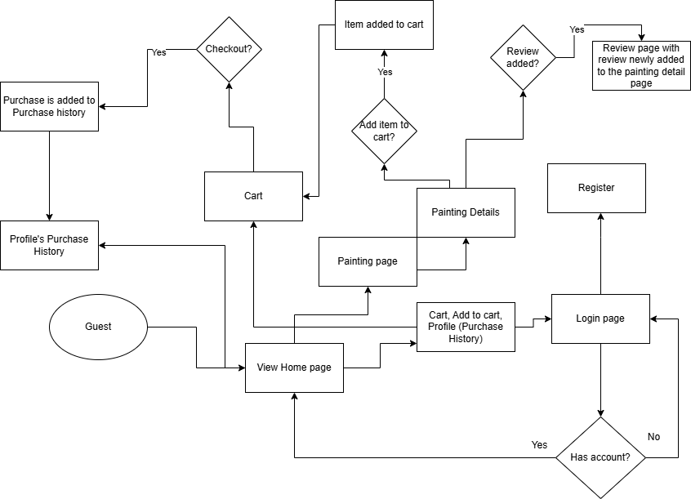

* 1. **Table assigning tasks to members (for Leader)**

*Note that the task assignment well is planned upon the capability and the availability of each member. The work contribution percentage can be well reflected by the table.

|  |  |  |  |  |  |
| --- | --- | --- | --- | --- | --- |
| **Index** | **Function** | **Function Detail** | **Priority** | **Recipient** | **Note** |
| 1 | Create Database |  | High | All |  |
| 2 | Drawing Diagram |  | High | All |  |
| 3 | Logo Design |  | Low | Vinh, Quang |  |
| 4 | Gathering photos |  | Low | Quang |  |
| 5 | User Middleware |  | Medium | Vinh |  |
| 6 | User Layout |  | Medium | Vinh |  |
| 7 | User UI |  | Medium | Vinh |  |
| 8 | User Function | Login / Register | High | Vinh |  |
| Filter + search product | High | Vinh |  |
| Cart / Checkout | High | Vinh |  |
| 9 | Admin Middleware |  | Medium | Minh |  |
| 10 | Admin Layout |  | Medium | Minh |  |
| 11 | Admin UI |  | Medium | Minh |  |
| 12 | Admin Function | Login / Register | High | Minh |  |
| CRUD | High | Minh |  |
| 13 | Weekly Report |  | High | All | Every Friday |
| 14 | Overall weekly review |  | High | Vinh |  |
| 15 | Report |  | Medium | Vinh, Quang |  |

**INSTRUCTION TO RUN THE PROJECT**

1. **XAMPP Setup**

Open XAMPP and Start module Apache and MySQL.

In case the configuration of these two modules does not work normally on your PC, please re-configure these modules by:

- Open the configuration as the image below

- Check the files in the report folder

- Copy the content of the file ‘httpd.conf.txt’ and paste it in the Apache configuration.

- Copy the content of the file ‘my.ini’ and paste it in the MySQL configuration.

1. **Import database and tables into SQL Server**

In the report folder, please use the file ‘paintingdb.sql’ as the import database

Access phpMyAdmin page: If you setup the XAMPP as the files provided in the previous step, the URL to the phpMyAdmin should be ‘http://localhost:8090/phpmyadmin/’.

After accessing it, create a new database named ‘paintingdb’ as in the image below.

Now, choose the ‘Import’ tab and choose the file ‘paintingdb.sql’ which is attached in the report folder. Then, click ‘Import’ at the end of the page.

By now, the database should be successfully created.

1. **Import Project into Visual Studio**

Open VS Code.

On the menu tab, choose ‘File’ tab and select ‘Open Folder’, then open the folder ‘painting’ attached in the report folder.

Open the Terminal section (at the bottom of the interface), your folder location should be displayed in it. In case you haven’t installed Laravel, please type ‘***composer global require laravel/installer’****.*

After completing the installation, in the Terminal section, after the directory to the project folder, please type in ‘***php artisan serve***’.

Wait for a few seconds, then the Terminal would return a link to the project page. Please use it to access the home page.

In case you want to stop the server, click on the Terminal section and press Ctrl + C.

1. **Run Web Application (Web User)** 
   * + - 1. Home Page: After accessing the link, here’s the home page.

* + - * 1. Paintings page: Here’s the Paintings page which shows all the paintings product of Galleria.

You can try the filter and search button here to retrieve the items based on the conditions you set. You can quickly reset all the filter/search results by using the Reset button.

* + - * 1. Painting Details page: Now, when you select a specific item, there will be a page showing all the detailed information about it. Note that the ‘Add to cart’ button is only available for logged in users only.

* + - * 1. Review: Lower on the page is the Detailed Information section.

Next is the Reviews tab. Here you can see reviews of other users and you can add a review yourself.

* + - * 1. Gallery page: Here’s the Gallery page, it shows random photos on each access.

* + - * 1. About us Page: Sharing our story and purpose in the community.

* + - * 1. Contact Page

* + - * 1. Cart and Profile: That’s all that a guest can visit. This is how header Cart and Profile looks like when you’re not logged in.

Now when you click on ‘View Cart’ or ‘Add to Cart’ or ‘Login’, a login page will appear. In case you don’t have an account, you can go to the registration form by clicking on ‘Sign up’. For your test, use this account (User Roler):

Username: test111; Password: 123123

With a logged in account, you can add an item to cart, quickly check it in the header cart and move to the cart page in case you’d like to check out.

In the cart page, you can check the information of the order before proceeding.  
The added item can be removed by clicking on the red minus-symbol button.  
In case you’d like to add up to the quantity of an item, click on the blue plus-symbol button and it will link you back to the product detail page, you can add the quantity there and the cart quantity will be updated.

* + - * 1. Checkout and Purchase History: We know that this process of adding/removing quantity is not a sufficient method but due to the personal restricted time, unfortunately the best could not be provided. This method is designed as the work-around option.

After checking out, the items will be removed from the cart. You can check the purchase history in the header profile.

That’s all for the function of logged in user. If you’re to log out, click on the header profile and choose to log out.

1. **Run Web Application (Web Admin)**
   * + - 1. Login

Login Admin Account

For your test, use this account (Admin Role):

Username: vinhadmin2; Password: 123456minh

* + - * 1. CRUD - Manage Related Information of Paintings, Customers, Orders

Accounts

Add Accounts

Edit Accounts

Order

Edit Order

Order Detail

Artist

Add Artist

Edit Artist

Gallery Subject

Review

Delete Review

1. **Database**
2. ER Diagram

1. Detail of Tables





**CONTRIBUTIONS**

